COMPUTER NETWORKS: ASSIGNMENT 2

**Student number:ST10467645 Full Name: Kandyce Jade Smit**

**Lecturer: Samuel Kubjana**

**Computer Networks 1A (CONE5111)**

Contents

Activity 1 – Network Architecture 2

Activity 2 – Network Segmentation 3

Activity 3 – Wide Area Networks (WANS) 6

Activity 4 – Wireless Transmissions 7

Activity 5 – Network Documentation 8

Bibliography 10

# Activity 1 – Network Architecture

**Network architecture for the Library & Multimedia technologies Center**

I have chosen to use a hybrid network setup that combines physical, virtual and cloud architecture to improve efficiency.

For the following I have chosen:  
  
**Physical Architecture**

Topology, Servers and Cabling:

* To ensure centralised control and easy expansion, the network uses a star-tree hybrid topology. The main departments connect to a core switch, which makes network management and troubleshooting easier. This also allows for scalability when adding new devices or departments. If one device fails, it will not affect the rest of the network as it will continue to function. (Geeks For Geeks, 2024).
* Servers One library server to manage the system and workstations along with an authentication server to manage users. (Server Watch, 2023).
* Cabling: CAT6 cables are used for standard connections, fiber optic cables for high-speed connections between switches and wireless access points are used for maximum Wi-Fi coverage, allowing consistent connectivity for both members and staff. (Spice Works, 2025).

**Virtual Architecture**

The virtual systems complement the physical setup by providing management and efficient use of resources.

User Authentication, IP Addressing and Network Management:

* User Authentication: When users log into the network, the system will determine if they are a member or staff, which determines their role, and level of access. This keeps the network organised and secure. (GeeksforGeeks, 2025).
* IP Addressing: By utilising classless inter-domain routing to properly assign IP addresses, the newly established network can have flexible subnetting and maximize the usable address space. Additionally, dynamic host configuration protocol allows the assigned IP address to automatically be given to the device as it connects to the network. This not only eliminates manual configuration but lowers the possibility of having conflicting IP addresses. (Mukul, 2025).
* Network Management: Switches and Routing - Using managed switches to control the flow of traffic within the network, where segmentation can be easily established to provide separate bandwidth to different departments or areas. Configuring routing protocols will help ensure the management of the use of the network. (TechTarget, n.d.).

**Cloud Architecture**

These cloud-based solutions for the Library & Multimedia technologies Center allow the network to be more flexible to future needs, making the entire infrastructure more scalable:

* Cloud Backups: As the center grows cloud-based backups should be implemented for critical data to ensure protection against data loss and support disaster recovery.
* Cloud Storage: For larger multimedia files that will reach excess of on-site storage, cloud storage can be used to expand the storage capacity without physical limitations.
* (IBM, 2024)

# Activity 2 – Network Segmentation

1. Broader Network Segmentation

The network can be segmented in the following ways to improve security, performance, and manageability:

* Physically Each department has its own switch connected to a central core switch (192.168.40.2). This allows network traffic to be managed and isolated per department, limiting congestion and possible interference.
* Virtually - Virtual LANs (VLANs) separate logical network traffic without incurring additional physical infrastructure. Each VLAN could be separated specifically for departments, for example:
  + VLAN 10 for the library.
  + VLAN 20 for the multimedia and technologies facility.
  + VLAN 30 for the connection lab.
  + VLAN 40 for the IT support office.
  + VLAN 50 for the server, security and access control room.
* (GeeksforGeeks, 2025)

1. Subnet masks

Subnet masks can be used to break the larger network into smaller, manageable sub-networks (subnets) to enhance the performance and security in the following way:

* /25 Subnet Mask (255.255.255.128): Ideal for smaller departments, offering up to 126 usable IP addresses. However, it is not ideal for the center as you cannot scale up the subnet mask.
* /24 Subnet Mask (255.255.255.0): Suitable for departments with a larger number of devices, providing up to 254 usable IP addresses. This makes it better suited for the center, as it supports efficient IP address allocation and future growth.
* (GeeksforGeeks, 2025)

1. Subnets and IP information  
     
   The IP address scheme that can be used across the whole network will be based on private Class C IP addresses (192.168.x.x), which are appropriate for small to medium-sized networks. Class C addresses allow a maximum of 254 hosts per network, so they are typically used for LANs (AWS, n.d.). As a bonus, using CIDR and VLSM allow for more efficient use of IP addresses by sub-dividing each Class C block into various sized subnets for each VLAN (Cisco, 2023; Comparitech, 2024).

Each VLAN can be assigned a dedicated subnet with assigned IPs based on private IP ranges such as 192.168.40.0/24, and break it down into /27 and /26 subnets for an even better flow of traffic, security, and logical separation of departments:

VLAN 10: The library

* Subnet range: 192.168.40.0/27
* Subnet mask: 255.255.255.224
* IP Range: 192.168.40.1 – 192.168.40.30
* Broadcast Address: 192.168.40.31

VLAN 20: The multimedia and technologies facility

* Subnet range: 192.168.40.32/27
* Subnet mask: 255.255.255.224
* IP Range: 192.168.40.33 – 192.168.40.62
* Broadcast Address: 192.168.40.63

VLAN 30: The connection lab

* Subnet range: 192.168.40.64/27
* Subnet mask: 255.255.255.224
* IP Range: 192.168.40.65 – 192.168.40.94
* Broadcast Address: 192.168.40.95

VLAN 40: The IT support office

* Subnet range: 192.168.40.96/27
* Subnet mask: 255.255.255.224
* IP Range: 192.168.40.97 – 192.168.40.126
* Broadcast Address: 192.168.40.127

VLAN 50: The server, security and access control room

* Subnet range: 192.168.60.0/26
* Subnet mask: 255.255.255.192
* IP Range: 192.168.60.1 – 192.168.60.62
* Broadcast Address: 192.168.60.63

The following reserved IP addresses can be used for:

* Library Server: 192.168.40.10
* Multimedia Server: 192.168.40.11
* Connection Lab Server: 192.168.40.12
* Security Server: 192.168.40.13
* Access Control System: 192.168.60.10
* Core Switch: 192.168.40.2
* Gateway Router: 192.168.1.1

(GeeksforGeeks, 2024; GeeksforGeeks, 2025).

1. Implementation of subnets on a network

Subnets for the library and multimedia technologies center can be utilised in the following ways by using VLANs, DHCP, routing protocols, and firewall rules combination:

* VLANs (Virtual LANs): Each department has an assigned VLAN on the core and access layer switches. This provides traffic separation logic, even though they may share the same physical switches. (GeeksforGeeks, 2023).
* DHCP (Dynamic Host Configuration Protocol): DHCP servers automatically assign IP addresses within each subnet which removes human errors and conflicts in address assignment. Each subnet will have its own DHCP scope. (TechTarget, 2023).
* Routing: Routing: A Layer 3 switch or the core router will have the capability to do routing between VLANs, it can be static or dynamic routing protocols. The overall goal for using an inter-VLAN routing device is so that departments can communicate with each other. In this case, the library could access the multimedia server but not the security system. (Cisco, 2020)
* Firewall: There are rules that can be applied using the access control lists (ACLs) and the firewall policies going between subnets to ensure that departments can only communicate if needed. (GeeksforGeeks, 2025)
* Switch Management: Managed switches allow for configuration per port, monitoring for traffic, and supports VLAN tagging. (Cisco, 2020).
* Wireless Segmentation: Wireless Access Points can support multiple SSIDs where each SSID is associated with a VLAN. In this case, staff-WiFi could be seperated from member-WiFi and ensure that the wireless devices are also being logically segmented correctly. (GeeksforGeeks, 2024).

# Activity 3 – Wide Area Networks (WANS)

1. **Endpoint Equipment**

The WAN infrastructure for the Library and Multimedia Technologies Center can have the following endpoint devices ensure that City1 and City2 can communicate with one another:

Routers

* Core routers for routing data between City1 and City2. (DRIVENETS, n.d.).
* Edge routers could be considered at each site to allow connection to the ISP and to manage WAN links. (ITU, n.d.)

Switches

* Layer 3 Switches can be used for inter-VLAN routing within City1 and City's networks.
* Access Switches to connect workstations, servers and other devices such as printers, scanners, copiers and security cameras.
* (ITU, n.d.)

Firewalls

* To secure WAN data traveling between websites and prevent unauthorised access. (ITU, n.d.; Cisco, n.d.).

Modems

* Allows Fiber connections at both sites. (ITU, n.d.)

Wireless Access Points

* To allow users, members, and guests to have Wi-Fi access on personal devices with traffic segmented using VLANs. (ITU, n.d.; Lenovo, 2025).

1. **WAN Connectivity**

The Library & Multimedia Technologies Center will benefit from using the following WAN connectivity types:

* MPLS (Multiprotocol Label Switching) - will provide high bandwidth, low latency connectivity between City1 and City2.
* Leased Lines – Can be used as a backup. For example, in the event of an MPLS failure, Fiber-optic leased lines can be used as a failover which guarantees the connection will be available for business continuity.
* VPN for Remote Access – Site-to-Site VPN may be used for secure connectivity in between City1 and City2 while SSL VPN will be used for remote IT administrators to manage the environment.
* ISPs - Each location will have two ISPs to ensure there are no downtimes for example, Fibre and LTE can be used as a backup.
* (Study-CCNA, n.d.)

Overall, this WAN design ensures scalability as additional branches can be added without having to redesign everything, security using firewalls, vpns and VLANs between sites will prevent unauthorised access, Reliability as MPLS and leased lines will ensure that downtime is kept to a minimum and Performance increase using an owned and managed WAN. (ITU, n.d.).

# Activity 4 – Wireless Transmissions

1. **Wireless Topology**

To provide complete wireless coverage and efficient connectivity for the Library & Multimedia Technologies Center at both City1 and City2, a hybrid wireless topology may be implemented (Kentik, n.d.). A hybrid wireless topology is both infrastructure mode and mesh networking (Mary E. Shacklett, 2025). The buildings will have wireless access points that will communicate with a single core switch within a star-tree physical topology. This layout will allow for a central point of control and scalability by allowing for additional access points to be added or taken away from the wireless network without disrupting the overall network. The library study area, connection labs, and IT offices will have access points with a predetermined location that allows for optimal coverage (ConceptDraw, n.d.). For outdoor spaces or between-building communication in City2, mesh networking ensures uninterrupted connectivity by allowing access points to wirelessly relay data to each other, even if one link goes down (Cisco, 2012). This setup supports high-speed access, reliability, and future growth. (Netgear, n.d.)

1. **Implementing a Wi-Fi Network**

The Wi-Fi network may utilize Wi-Fi 6 dual-band access points utilizing both the 2.4GHz and 5GHz frequencies, which offers high speed and will be compatible (TechTarget, 2020). The access points will be connected to managed switches using CAT6 or Fiber optic cables to maintain as high a speed as possible with low latency (CablesandKits, n.d.). Each access point can broadcast multiple SSIDs, for example, “CenterStaff” and “CenterMember” while also VLAN tagging the access points to separate traffic (ServerFault, 2019). The “CenterStaff” could be VLAN 40 and the “CenterMember” VLAN 10, and the firewall rules would determine what traffic is permitted or denied between the two. DHCP servers can also be used to automatically assign IP addresses to each device and ensure the devices utilise the correct subnet for access and avoiding IP address conflicts (GeeksForGeeks, 2024). Staff can be authenticated using a radius server (Cisco, 2024), and guests will authenticate for secure access using a captive portal (TechTarget, n.d.). The Wi-Fi could be viewed and managed through a management dashboard that is presented in the cloud. This allows for real-time control and troubleshooting from both cities as well as updates, creating a network that is secure, scalable, and easy to manage. (TechGuide, n.d.)

# Activity 5 – Network Documentation

**Screenshot of Topology Diagram**

* The following network topology diagram was created using Cisco Packet Tracer (Cisco Networking Academy, 2024).

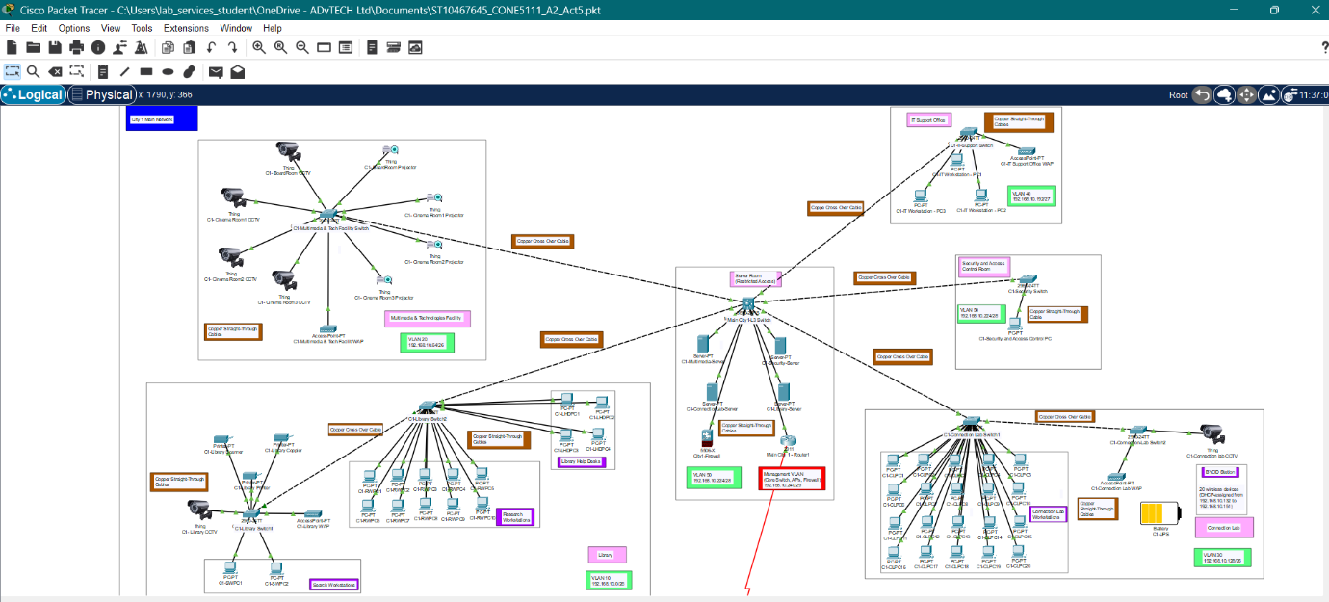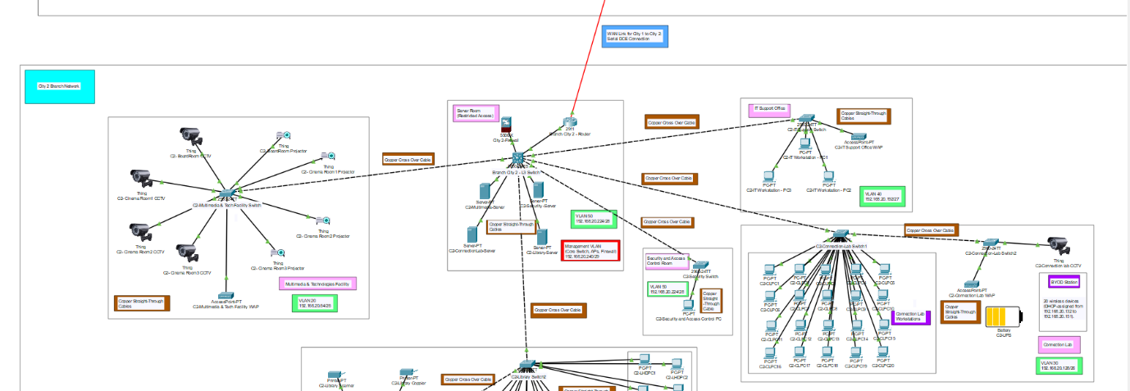

**A short description of what the diagram is about**

The screenshots above are of my network topology that I created in Cisco Packet Tracer (Cisco Networking Academy, 2024) for City 1 (main network) and City 2 (branch network). The diagram shows all the departments that were required: Library (VLAN 10), Multimedia Center (VLAN 20), Connection Lab including BYOD devices area (VLAN 30), IT Support (VLAN 40), and secured areas like the Security & Server Room (VLAN 50). I configured the separate VLANs for all departments and configured proper IP addressing that utilised VLSM subnets (for example, BYOD - 192.168.10.128/26). The two cities connect to one another via a serial WAN link (10.0.0.0/30) connecting the routers. I have used router-based DHCP that allows automatic IP assignment, which allows City 1 router to administrate the main network VLANs and City 2 router to administrate branch devices. I have also included firewalls (ASA 5506-X) to limit access between VLAN's and provide security to highly sensitive network areas. After configuring all devices, I made sure to test connectivity by making sure devices within VLANs can communicate, BYOD is isolated, and both cities are able to share information via the WAN link. My topology uses clear labelling for all devices and connections.

# Bibliography

AWS, n.d. *What is CIDR?.* [Online]   
Available at: https://aws.amazon.com/what-is/cidr/?utm  
[Accessed 8 May 2025].

CablesandKits, n.d. *Fiber Optic vs. Ethernet Cables: Which One’s Right for Your Network?.* [Online]   
Available at: https://www.cablesandkits.com/learning-center/fiber-optic-vs-ethernet-cables  
[Accessed 09 May 2025].

Cisco Networking Academy, 2024. *Cisco Packet Tracer (Version 8.2.2).* s.l.:s.n.

Cisco, 2012. *Cisco Wireless Mesh Access Points, Design and Deployment Guide, Release 7.3.* [Online]   
Available at: https://www.cisco.com/c/en/us/td/docs/wireless/technology/mesh/7-3/design/guide/Mesh/Mesh_chapter_01.html  
[Accessed 09 May 2025].

Cisco, 2020. *Configure Port to VLAN Interface Settings on a Switch through the CLI.* [Online]   
Available at: https://www.cisco.com/c/en/us/support/docs/smb/switches/cisco-small-business-300-series-managed-switches/smb5653-configure-port-to-vlan-interface-settings-on-a-switch-throug.html  
[Accessed 07 May 2025].

Cisco, 2020. *Inter-VLAN Routing.* [Online]   
Available at: https://www.ciscopress.com/articles/article.asp?p=3089357&seqNum=6&utm_source=chatgpt.com  
[Accessed 07 May 2025].

Cisco, 2023. *Configure IP Addresses and Unique Subnets for New Users.* [Online]   
Available at: https://www.cisco.com/c/en/us/support/docs/ip/routing-information-protocol-rip/13788-3.html  
[Accessed 08 May 2025].

Cisco, 2024. *Examine how the RADIUS Works.* [Online]   
Available at: https://www.cisco.com/c/en/us/support/docs/security-vpn/remote-authentication-dial-user-service-radius/12433-32.html  
[Accessed 09 May 2025].

Cisco, n.d. *What is a firewall?.* [Online]   
Available at: https://www.cisco.com/site/us/en/learn/topics/security/what-is-a-firewall.html?  
[Accessed 08 May 2025].

Comparitech, 2024. *Variable Length Subnet Mask (VLSM) Tutorial.* [Online]   
Available at: https://www.comparitech.com/net-admin/variable-length-subnet-mask-vlsm-tutorial/  
[Accessed 08 May 2025].

ConceptDraw, n.d. *Extended-wireless-network-diagrams.* [Online]   
Available at: https://www.conceptdraw.com/examples/extended-wireless-network-diagrams  
[Accessed 09 May 2025].

DRIVENETS, n.d. *What Is a Core Router?.* [Online]   
Available at: https://drivenets.com/resources/education-center/what-is-a-core-router/?utm_source=chatgpt.com  
[Accessed 08 May 2025].

Geeks For Geeks, 2024. *Advantages and Disadvantages of Tree Topology.* [Online]   
Available at: https://www.geeksforgeeks.org/advantages-and-disadvantages-of-tree-topology/  
[Accessed 08 March 2025].

GeeksforGeeks, 2023. *Virtual LAN (VLAN).* [Online]   
Available at: https://www.geeksforgeeks.org/virtual-lan-vlan/  
[Accessed 07 May 2025].

GeeksForGeeks, 2024. *Dynamic Host Configuration Protocol (DHCP).* [Online]   
Available at: https://www.geeksforgeeks.org/dynamic-host-configuration-protocol-dhcp/  
[Accessed 09 May 2025].

GeeksforGeeks, 2024. *How to Implement Wireless Network Segmentation and Why it is Important?.* [Online]   
Available at: https://www.geeksforgeeks.org/how-to-implement-wireless-network-segmentation-and-why-it-is-important/  
[Accessed 07 May 2025].

GeeksforGeeks, 2024. *Subnet Mask Cheat Sheet.* [Online]   
Available at: https://www.geeksforgeeks.org/subnet-cheat-sheet/  
[Accessed 07 May 2025].

GeeksforGeeks, 2025. *Introduction of Firewall in Computer Network.* [Online]   
Available at: https://www.geeksforgeeks.org/introduction-of-firewall-in-computer-network/  
[Accessed 07 May 2025].

GeeksforGeeks, 2025. *Introduction To Subnetting.* [Online]   
Available at: https://www.geeksforgeeks.org/introduction-to-subnetting/  
[Accessed 07 May 2025].

GeeksforGeeks, 2025. *Role of Subnet Mask.* [Online]   
Available at: https://www.geeksforgeeks.org/role-of-subnet-mask/  
[Accessed 07 May 2025].

GeeksforGeeks, 2025. *What is Network Segmentation?.* [Online]   
Available at: https://www.geeksforgeeks.org/what-is-network-segmentation/  
[Accessed 07 May 2025].

GeeksforGeeks, 2025. *What is User Authentication, and Why is it Important?.* [Online]   
Available at: https://www.geeksforgeeks.org/what-is-user-authentication-and-why-is-it-important/  
[Accessed 06 May 2025].

IBM, 2024. *What is cloud architecture?.* [Online]   
Available at: https://www.ibm.com/think/topics/cloud-architecture  
[Accessed 06 May 2025].

ITU, n.d. *What Is a Network Endpoint?.* [Online]   
Available at: https://www.ituonline.com/tech-definitions/what-is-a-network-endpoint/#:~:text=Network%20endpoints%20vary%20based%20on%20their%20purpose%2C%20functionality%2C,as%20intermediary%20devices%20with%20endpoint%20capabilities.%20More%20items  
[Accessed 08 May 2025].

Kentik, n.d. *Network Topology, Mapping, and Visualization.* [Online]   
Available at: https://www.kentik.com/kentipedia/what-is-network-topology/  
[Accessed 09 May 2025].

Lenovo, 2025. *What is a wireless access point (WAP)?.* [Online]   
Available at: https://www.lenovo.com/us/en/glossary/wireless-access-point/?orgRef=https%253A%252F%252Fchatgpt.com%252F&srsltid=AfmBOop1z-lU-4LEo60KQaXNDl9YFd6nqJtq30X7DerNj-ro89iU8kKY&utm  
[Accessed 08 May 2025].

Mary E. Shacklett, T. D. C. J. T. J. G., 2025. *What is a wireless mesh network (mesh WiFi)?.* [Online]   
Available at: https://www.techtarget.com/searchnetworking/definition/wireless-mesh-network  
[Accessed 09 May 2025].

Mukul, M., 2025. *Mastering CIDR: A Guide to IP Addressing and Subnetting.* [Online]   
Available at: https://monowar-mukul.medium.com/mastering-cidr-a-guide-to-ip-addressing-and-subnetting-d1ab3495e07a  
[Accessed 06 May 2025].

Netgear, n.d. *What is Mesh WIFi?.* [Online]   
Available at: https://www.netgear.com/hub/technology/what-is-mesh-wifi/  
[Accessed 09 May 2025].

ScienceDirect, n.d. *Star Topology.* [Online]   
Available at: https://www.sciencedirect.com/topics/computer-science/star-topology  
[Accessed 09 May 2025].

Server Watch, 2023. *What Is a Server? | Definition, Types, and Features.* [Online]   
Available at: https://www.serverwatch.com/guides/what-is-a-server/  
[Accessed 08 March 2025].

ServerFault, 2019. *How does VLAN tagging work when the AP is connected to a single subnet?.* [Online]   
Available at: https://serverfault.com/questions/989729/how-does-vlan-tagging-work-when-the-ap-is-connected-to-a-single-subnet  
[Accessed 09 May 2025].

Spice Works, 2025. *What Is Network Hardware? Definition, Architecture, Challenges, and Best Practices.* [Online]   
Available at: https://www.spiceworks.com/tech/networking/articles/what-is-network-hardware/#:~:text=Network%20hardware%20is%20a%20set%20of%20physical%20or,enable%20a%20network%20to%20function%20effectively%20and%20efficiently.  
[Accessed 08 March 2025].

Study-CCNA, n.d. *WAN Connection Types – Explanation and Examples.* [Online]   
Available at: https://study-ccna.com/wan-connection-types/  
[Accessed 08 MAy 2025].

TechGuide, n.d. *What is Cloud Managed WiFi? Explained Simply.* [Online]   
Available at: https://techguide.carrd.co/  
[Accessed 09 May 2025].

TechTarget, 2020. *Wi-Fi 6 explained: Speed, range, latency, frequency and security.* [Online]   
Available at: https://www.techtarget.com/searchnetworking/feature/Wi-Fi-6-technology-explained-from-speed-to-security-and-more  
[Accessed 09 May 2025].

TechTarget, 2023. *DHCP (Dynamic Host Configuration Protocol).* [Online]   
Available at: https://www.techtarget.com/searchnetworking/definition/DHCP  
[Accessed 07 May 2025].

TechTarget, n.d. *Captive Portal.* [Online]   
Available at: https://www.techtarget.com/searchmobilecomputing/definition/captive-portal  
[Accessed 09 May 2025].

TechTarget, n.d. *network segmentation.* [Online]   
Available at: https://www.techtarget.com/searchnetworking/definition/network-segmentation  
[Accessed 06 May 2025].